Mechanical Overview

Year: 2023 Semester: Spring Team: 10 Project: Parking Tracking System

Creation Date: ­February 7, 2023 Last Modified: February 11, 2023

Author: Fred Kepler Email: fkepler@purdue.edu

Assignment Evaluation:

|  |  |  |  |  |
| --- | --- | --- | --- | --- |
| **Item** | **Score (0-5)** | **Weight** | **Points** | **Notes** |
| **Assignment-Specific Items** | | | | |
| **Commercial Packaging Analysis 1** |  | x2 |  |  |
| **Commercial Packaging Analysis 2** |  | x2 |  |  |
| **CAD Model Illustrations** |  | x4 |  |  |
| **Project Packaging Specifications** |  | x2 |  |  |
| **PCB Footprint Layout** |  | x2 |  |  |
| **Writing-Specific Items** | | | | |
| **Spelling and Grammar** |  | x2 |  |  |
| **Formatting and Citations** |  | x1 |  |  |
| **Figures and Graphs** |  | x2 |  |  |
| **Technical Writing Style** |  | x3 |  |  |
| **Total Score** |  | | |  |

5: Excellent 4: Good 3: Acceptable 2: Poor 1: Very Poor 0: Not attempted

Comments:

*Comments from the grader will be inserted here.*

1. Commercial Product Packaging

Our team analyzed two commercial products that are similar to our Parking Tracking System. These products include the Smart Parking SmartSensor [2], and the Monnit Wireless Vehicle Detect/Counter Sensor [3].

* 1. Product #1

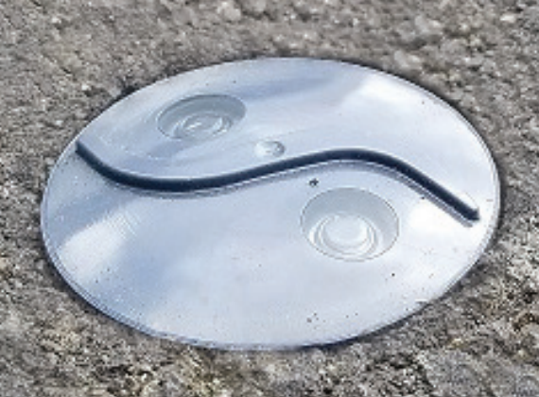

Figure 1: Smart Parking SmartSensor [2]

The Smart Parking ecosystem is made up of two hardware devices: the SmartSensor and the SmartSpot Gateway. The SmartSensor is shown above in figure 1, while the SmartSpot Gateway is shown below in figure 2. This setup is similar to how our Parking Monitoring System is going to be setup with the Car Detector Module (CDM) and the Aggregator Module (AM). The analysis is going to be split up into two parts.

First up is the SmartSensor. This sensor is housed in a weather-resistant packaging that provides protection against the elements. Some of these elements include temperature changes, water, and dust. Since it is embedded into the ground, it also has to be vibration and impact resistant. It is packaged in plastic that protects it from these variables. This sensor is also lightweight and compact [2]. Inside the packaging, it contains the power source, the sensor, and the communication capabilities.

The SmartSensor has similar functionality to the CDM in our Parking Tracking System. This means that there are some similarities when it comes to the considerations needed when creating a casing for the CDM. Some of these similarities include its ability to resist some of the same elements such as temperature changes, water, and dust. Also, the CDM is going to be relatively compact and lightweight. The main difference is the placement of the sensors. While the SmartSensor is designed to be embedded into the ground, our CDM is intended to be mounted. When maintaining proper usage, the CVDM will not have to factor in as much impact and vibration protection as the SmartSensor. However, these variables will definitely have to be accounted for, just less severely.

Next up is the SmartSpot Gateway. This gateway has similar packaging considerations as the SmartSensor. It is intended to be mounted somewhere within communication range of the SmartSensors. In turn, it has to be able to withstand some of the same elements. These elements include temperature changes, water, dust, vibration, impact, and low/high light. It is packaged in plastic that protects it from these variables. It also takes into consideration that the gateway needs to have easy access for maintenance and various upgrades [1]. Since it contains more hardware, the gateways tend to be less compact and lightweight as the SmartSensors. They typically house the power source, a processing unit, and the communication capabilities. Since it is intended to be mounted, the gateways come with proper mounting equipment, such as brackets/poles.

The SmartSpot Gateway has similar functionality to the AM in our Parking Tracking System. This means that there are some similarities when it comes to the considerations needed when creating a casing for the AM. Some of these similarities include the ability to resist some of the same elements such as temperature changes, water, dust, vibration, impact, and low/high light. Also, we plan to mount the AM similarly to the SmartSpot Gateway. This means that we will have to include proper mounting equipment like the gateway. The key difference between the products will be the size and weight. Our team plans to keep the AM relatively compact and lightweight compared to the SpartSpot Gateways.

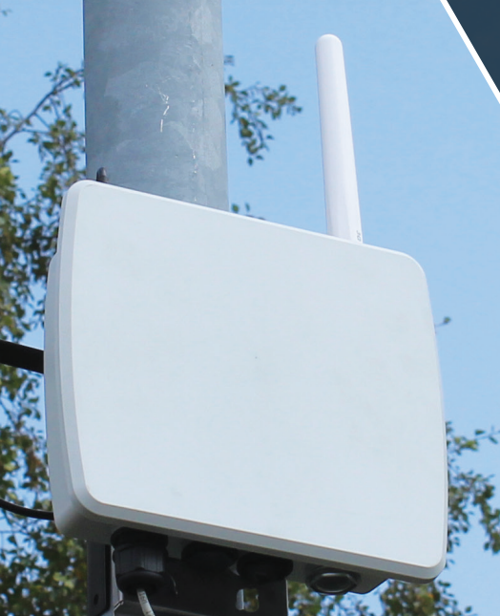

Figure 2: Smart Parking SmartSpot Gateway [1]

* 1. Product #2

Figure 3: Monnit Wireless Vehicle Detect/Counter Sensor [3]

Next up is the Monnit Wireless Vehicle Detect/Counter Sensor. This sensor has a different packaging design than the Smart Parking products discussed in section 1.1. It is intended to be mounted somewhere within 9 feet of the collection of data [3]. This is because the actual sensor is connected to the processing module through a 9-foot hose. Let’s first talk about the packaging of the sensor and hose. The sensor is intended to be mounted to any surface that has the capability to utilize the mounting spikes that it comes with. The casing of the sensor is made to be able to withstand the common elements shared with the previous commercial product. These elements include temperature changes, water, dust, vibration, impact, and low/high light. It is then wired through a 9-foot hose. This hose is designed to protect the wiring from all the various conditions explained previously. Next, we will talk about the main housing. Since it contains a lot of important hardware, the main housing is a lot sturdier, heavier, and bigger. They typically house the power source, a processing unit, and the communication capabilities. These components are protected with a metal casing made to protect the hardware from the same elements we talked about previously with added strength. Since it is intended to be mounted, the main housing comes with proper mounting equipment, such as brackets/poles.

The Monnit Wireless Vehicle Detect/Counter Sensor comes in a different form factor than our planned implementation of the Parking Tracking System. As discussed previously, the main difference is the fact that the sensor is connected to the main housing through a hose. While this is a very big difference in design, this does not mean that there are not some similarities between the design considerations we need to think about. For example, while we do not plan to connect our CDM to the AM with a hose, we still plan to tailor the packaging to the different needs of the CDM and the AM.

2.0 Project Packaging Description

The first project package created was for the Car Detector Module (CDM). It is shown in figure 4. It contains a main housing, and a lid that is fastened on. The main housing is mainly just a box to protect all the components contained within the CDM. Also, it has a couple holes to allow the HC-SR04 ultrasonic sensor to work properly. It also has a hole to allow for the recharging of the battery pack. The lid has a transparent window to allow for the checking of status LEDs on the inside of the main housing.

The second project package created was for the Aggregator Module (AM). It is shown in figure 5. It contains a main housing, two 7-segment displays, and a transparent cover for the displays. The main housing is mainly just a box to protect all of the components contained within the AM. Also, it has a hole for the power source to connect through. The 7-segment displays will sit on top of the open ended main housing, and be covered by the transparent shield. This transparent cover is designed to protect the hardware that it contains, while also allowing the displays to be visible to the parker.

3.0 Sources Cited

[1] S. parking, “SmartSpots,” *Smart parking*, 07-Apr-2022. [Online]. Available: https://www.smartparking.com/smartpark-system/smart-spots. [Accessed: 07-Feb-2023].

[2] S. parking, “Vehicle detection sensors,” *Smart parking*, 07-Apr-2022. [Online]. Available: https://www.smartparking.com/smartpark-system/smart-sensors. [Accessed: 07-Feb-2023].

[3] “Wireless Vehicle Detection & Counter Sensor,” *Wireless Vehicle Detect-Counter Sensors for IoT Remote Monitoring*. [Online]. Available: https://www.monnit.com/products/sensors/vehicle/detection-counting/. [Accessed: 07-Feb-2023].

Appendix 1: CAD Model Illustrations

Figure 4: CAD Model of CDM

Key Dimensions

* Length: 193.5 mm
* Width: 95 mm
* Height: 90 mm
* Wall Thickness: 5 mm
* USB Port Width: 10 mm
* USB Port Height: 5 mm
* HC-SR04 Sensor Diameter: 16 mm
* Fastening Hole Diameter: 3 mm
* Fastening Hole Depth: 5 mm
* Window Width: 45 mm
* Window Height: 45 mm

Figure 5: CAD Model of AM

Key Dimensions

* Back Box Height: 178 mm
* Back Box Width: 75 mm
* Back Box Length: 228 mm
* 7-Segment Height: 178 mm
* 7-Segment Width: 35 mm
* 7-Segement Length: 238 mm
* Transparent Case Height: 188 mm
* Transparent Case Width: 45 mm
* Transparent Case Length: 248 mm
* Hole Height: 20 mm
* Hole Width: 20 mm
* Wall Thickness: 5 mm

Appendix 2: Project Packaging Specifications

Materials List:

|  |  |  |  |
| --- | --- | --- | --- |
| Material | Quantity | Weight | Cost |
| Plastic | 200 in^2 | 3.84 lbs | $22.70 |
| Clear Plastic | 100 in^2 | 1.92 lbs | $19.29 |
| Screws | 4 | 0.28 lbs | $4.23 |

Tooling Requirements:

|  |  |
| --- | --- |
| Tooling | Cost |
| Screwdriver | $2.11 |
| Plastic Cutter | $4.91 |

Appendix 3: PCB Footprint Layout

Figure 6: PCB Footprint Layout for CDM

Key Dimensions

* Length: 175 mm
* Width: 75 mm

*Figure 6 Not To Scale*

Figure 7: PCB Footprint Layout for AM

Key Dimensions

* Length: 150 mm
* Width: 200 mm

*Figure 7 Not To Scale*